How My Parents Learned to Eat
Ina R. Friedman

Book Description:

- A little girl tells the story of how her parents met in Japan and impressed one another over different cultural dinner choices/eating patterns.

Academic Objective:

- M2D1 Students will create simple tables and graphs and interpret their meaning.
a. Organize and display data using picture graphs, Venn diagrams, bar graphs, and simple charts/tables to record results.
b. Know how to interpret picture graphs, Venn diagrams, and bar graphs.

Brilliant Star Objective:

- Cognitive/Thinking: Classification: Students will be able to organize given elements into sets according to a specified rule or common attributes.
- Social/Cultural: Students will be able to identify physical, gender, social, ethnic and cultural factors that contribute to people being alike and different.

Essential Question:

- Do people in different countries eat the same foods?

Activating Strategy:

- Read How My Parents Learned To Eat by Ina R. Friedman

Present:

- Remind students about processes of categorizing, comparing, and contrasting.
- Remind students how to develop a Venn diagram

Venn Diagram
The Venn Diagram is made up of two or more overlapping circles. It is often used in mathematics to show relationships between sets. In language arts instruction, Venn Diagrams are useful for examining similarities and differences in characters, stories, poems, etc.
It is frequently used as a prewriting activity to enable students to organize thoughts or textual quotations prior to writing a compare/contrast essay. This activity enables students to organize similarities and differences visually.
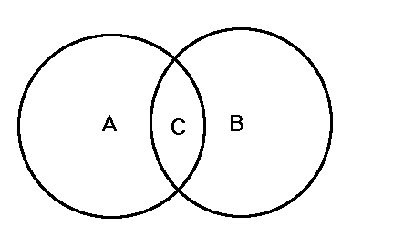

Guided Practice
- Organize class into cooperative teams ("Restaurant Owners"). Their job is to use the Internet to research information on Japanese and American staple foods: rice and potatoes. Each group will complete a Venn Diagram to compare and contrast these foods.
  - The Potato Plant: http://www.sunspiced.com/pplant.html
  - Potato Farming Images: http://www.idahopotato.com/Images/photos.html
  - History and Origin of the Potato: http://www.sunspiced.com/phistory.html
  - The Rice Plant: http://www.askasia.org/image/drawing/i000525.htm
  - How Was Rice Growing Introduced to Japan? http://www.jinjapan.org/kidsweb/japan/i/q7.html
  - Rice Growing in California: http://www.askasia.org/image/photos/tabi25.htm
  - Rice Growing in Japan: http://www.okome.com/picture1e.html

Return to:

  - Brilliant Star Main Page
  - Brilliant Star Reading Project: | Index |

